* **Stock Transfer**

1. Click the Menu
2. Click the Transaction
3. Click the Stock Transfer icon

Transaction

Stock Transfer

Menu

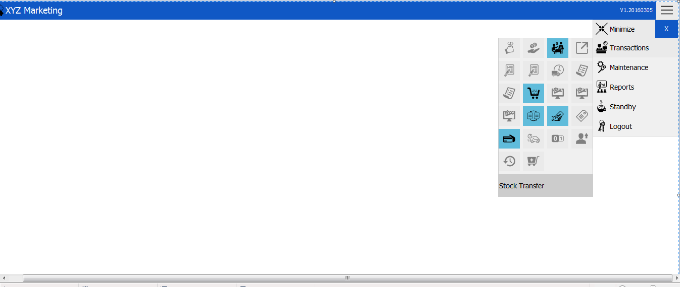

* **New Stock Transfer Transaction**

1. Choose Source Branch
2. Choose Destination Branch
3. Input or Search an Item
4. Click Post
5. Finalize the transaction

Transaction Number

Destination Branch

Post

Finalized

Destination Location

Source Branch

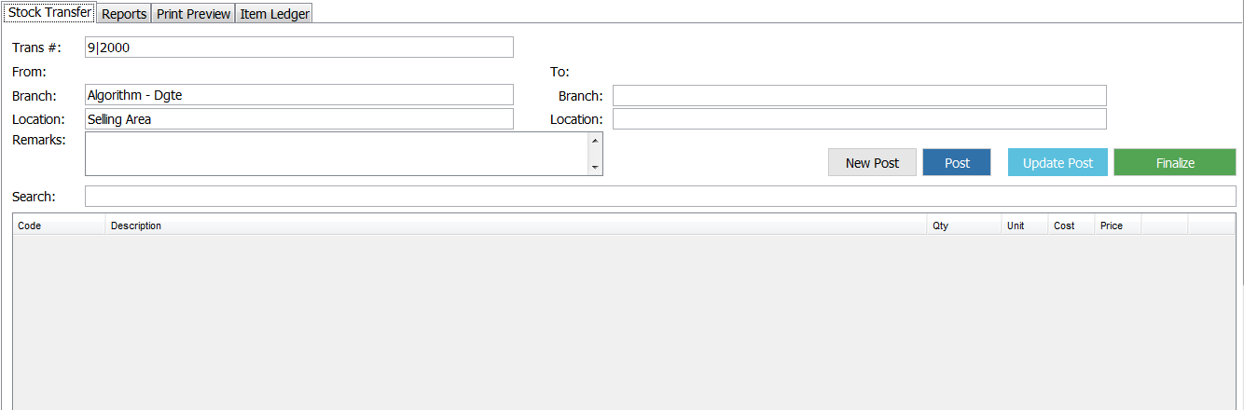

Source Location

1. Transaction Number



**Note: Transaction number is default and fixed. Hence, you cannot change nor delete it.**

1. Selecting Source Branch

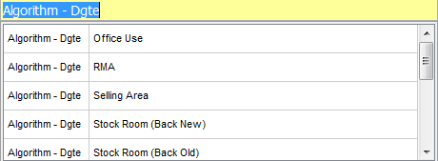

**Algorithm – Dgte is default. Once you choose, your chosen one will be placed on the source location under the source branch tab.**

1. Source Location
2. Selecting Destination Branch

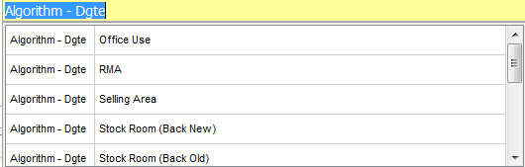

**Algorithm – Dgte is also a default. Once you choose, your chosen one will be placed on the destination location under the destination branch tab.**

1. Destination Location
2. Search

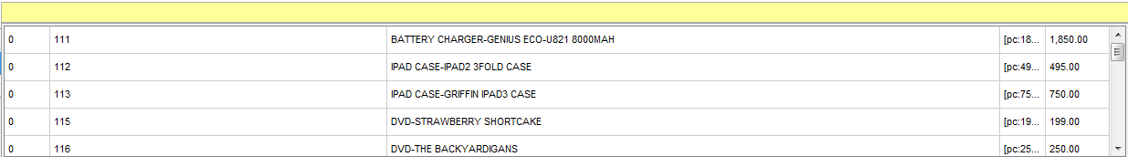

**Note: You can search item by using:**

1. **Item name/code**
2. **Barcode (Input/Scan)**
3. **Item description**
4. **In case you don’t know the code, you can just press enter for the item list.**

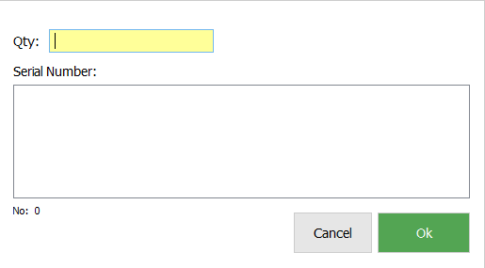6.1 Input the Quantity

**Input the Quantity and then press OK button.**

6.2 Update and Delete

Click to Delete

Click to Update

1. C:\Users\Guinness\Documents\Documents\User Manual\SMIS\Receipts\post.pngPost - **After filling up the stock transfer details, click the “POST” button in the middle right corner of your window**

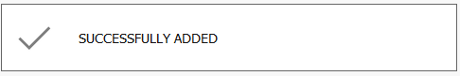**A message will appear if you successfully posted**

1. Finalizing Transaction
2. **Go to the “Reports tab”.**
3. **Search and select the transaction to be reviewed or finalized.**
4. **In the Status tab, right click the posted status and then finalize stock transfer.**

**Note: Only the privilege one can finalize the transaction.**

* **Reports**

Branch

Update

Search Filters

Status

Search

Delete

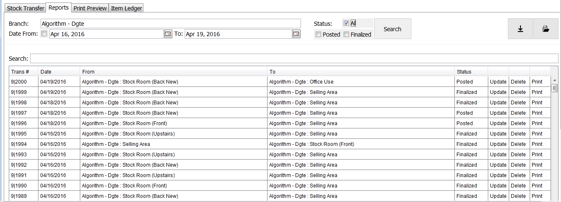

Print

List of Transactions

1. **Branch**

**Note: Algorithm – Dgte is the default branch name**

1. **Search Filter**

2.1  **Date- Choose date intervals or select the checkbox to view transactions regardless of the date.**

2.2 **Status- Show transactions depending on the selected checkbox.(All/Posted/Finalized).**

2.3 **Search- Display transactions with transaction numbers that matches the search item.**

1. **Search bar – Where you are going to input item to be search.**
2. 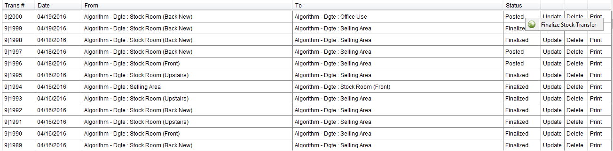**Item Status- Displays transaction’s current status (Posted/Finalized). If posted, you can directly finalize the transaction. Just right click->click “Finalized Stack Transfer”.**
3. **Update/Review**

**5.1 Click the “Update” label and you will be redirected to the “Stock Transfer Tab”.**

**5.2 Check and edit the transactions for wrong entries. Click ok.**

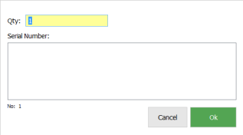

* + 1. 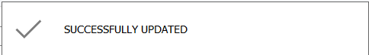 **A message box will appear if you successfully updated.**

**5.3 Click the “Finalized” button at the right corner of your screen.**



1. **Delete – It deletes posted transactions only. Finalized transactions cannot be deleted anymore.**
2. **Print/ Print Preview Tab – Shows stock transfer details.**

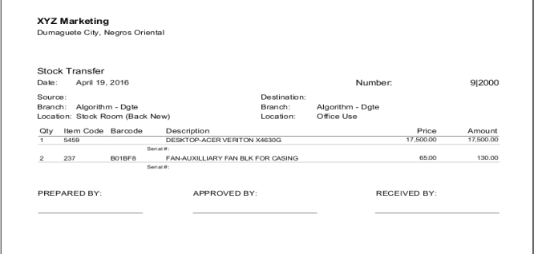

1. **List of Transactions**



* **Item Ledger**

Search Filters

Location

Date

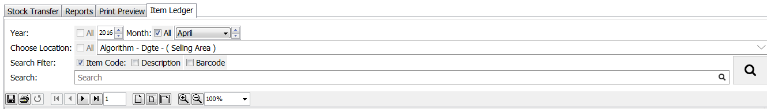

Search

1. **Select inclusive date. (Yearly or monthly)**



1. **Select location**

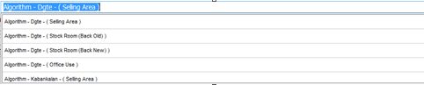

1. **Input the item you want to search in the search tab. (Item code/Description/Barcode)**



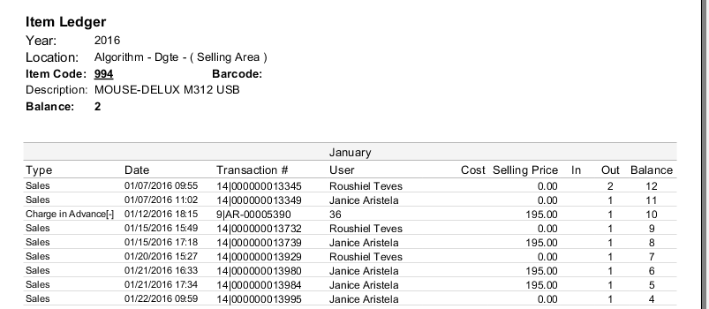Example of an Item Ledger